# MD-100 Modern Desktop Administrator

## Module 1: Installing Windows

### Introducing Windows 10

#### What’s new in Windows 10

* Start screen and start menu improvements.
* Cloud integration

**Recovery tools:**

* Reset this pc
* Advanced start-up options

**Virtualization:**

* Client Hyper-V
* Windows Sandbox – provides a lightweight desktop environment for temporarily running apps in an isolated environment. Creates a pristine install of windows, isolated from the host and without the need to download or create a separate VHD. When closed, everything is discarded.

**Mobility Improvements:**

* Support for multiple device types - Hololens – one of the first holographic computers. Many uses for educational purposes, design and constructing businesses.
* BYOD – bring your own device to connect to corporate networks.
* Mobile broadband
* Broadband tethering – can turn windows 10 device into a wifi hotspot
* Auto-triggered VPN – if an app requires access to your companys intranet, windows 10 can automatically trigger a vpn connection.

**Security enhancements:**

* Remote business data removal – windows 10 and windows server you can use remote business data removal to classify and flag corporate files and to differentiate between these files and user files. With this classification, the remote wipe of a windows 10 device will not remove user-owned data when securing or removing corporate data on the device.
* Improved biometrics – windows sign-in, remote access, and user account control.
* Pervasive device encryption – on Microsoft surface devices, device encryption is enabled by default and you can configure additional bitlocker driver encryption protection. Can also enable additional management capability on the windows 10 pro and enterprise editions.
* Malware resistance – windows defender now includes network-behaviour monitoring that can help to detect and prevent the execution of known and unknown malware.
* Device lockdown – the assigned access feature enables you to restrict the windows store app experience on a device to specific subset of apps, or even to a single app. This could be a line-of-business app in a kiosk scenario, or a set of educational apps for children in a school setting.
* Virtual secure mode – a secure process-exectution environment that windows 10 introduces. Helps protect system processes by running them in a separate, virtualized container, known as a trustlet, rather than in the operating system itself. Because the windows operating system does not have access to these trustlets, processes and data within them are safer.
* Nearby sharing – lets you instantly share your videos, photos, docs and websites with people and devices near you over Bluetooth or wifi.

#### Benefits of Windows 10 for small and medium-sized organisations

* Easier to use
* Continuous updates
* Improved device management
* Distribution of apps by using the windows store
* More secure

#### Managing desktops in an enterprise environment

By allowing users to manage their own computers, the following problems could occur

* Software update problems
* Anti-malware problems
* Application management
* Hardware support

to more efficiently manage a large fleet of computers, enterprises often use one or more standard operating environments (SOE’s). an SOE is a set operating system, app, and hardware configuration. SOEs have the following benefits:

* Simplified deployment of new and replacement computers
* Consistent apps and hardware
* Simplified inventory
* Simplified updating
* Simpler software deployment

### Windows 10 editions and requirements

#### windows 10 editions and capabilities

**Windows editions:**

Windows 10 home –

Windows 10 pro –

Windows 10 pro for workstations –

Windows 10 enterprise –

Windows 10 enterprise LTSC –

Windows 10 pro education –

Windows 10 education –

### Installation methods

**Install methods:**

In-place upgrade

New deployment

Refresh

Provisioning

Migration (wipe-and-load, side-by-side)

**Three main methods for activation of windows 10:**

Retail

OEM

Microsoft volume licensing – a series of software licensing programs that are tailored to the size and purchasing methods of your organisation. Volume customers set up volume licensing agreements with Microsoft. These agreements include windows upgrade benefits and other benefits related to value-added software and services. MVL customers use volume activation services to assist in activation tasks, which consist of AD based activation, key management service and multiple activation lkey models.

**Volume activation models:**

Active directory-based activation

KMS – key management service

MAK – multiple activation key

**Process of upgrading to windows 10:**

Evaluate – backup – upgrade – verify – update

**Supported upgrade paths:**

Windows 8.1 update

Windows 8.1 RTM

Windows 8

Windows RT

Windows 7 SP1

Windows 7 RTM

**Process of migrating to windows 10**

Backup – install windows 10 – update – install apps – restore

### upgrading and migrating to windows 10

#### common upgrade and migration scenarios

### deployment methods

#### deployment options for windows

* Windows autopilot
* In-place upgrade

These methods are supported with existing tools (like Microsoft deployment toolkit MDT) or configuration manager.

OOBE – out of box experience

#### client virtualization

* Client hyper-v
* Windows sandbox

#### Deployment strategies

* Microsoft intune
* Config manager
* MDM

APN – apple push notification

#### imaging and autopilot

#### deployment tools

ADK

DISM

Windows SIM

Windows PE

Windows config designer

USMT

VAMT

Windows performance toolkit

ACT

Microsoft assessment and planning toolkit

Windows analytics upgrade readiness

Desktop deployment center

#### user state migration tool

## Module 2 – Configuring authorization and authentication

### Authentication

#### what are authentication and authorization

#### User account types

#### Managing local users

#### domains and workgroups

#### credential manager

#### windows hello

#### configuring password policies and user properties

#### user profiles and their contents

### managing users and groups

#### active directory overview

#### using active directory users and groups

#### using azure active directory

#### signing in to a domain

### configuring user account control

#### what is uac

#### how uac works

#### uac elevation prompts

#### configuring uac notification settings

### Implementing device registration

#### challenges to data access for multiple device types

#### microsoft device strategy framework

Mxtoolbox.com = is a domain name lookup tool

#### overview of device registration

#### how does device registration work?

#### infrastructure requirements to support device registration

#### registering and enrolling devices

## Module 3

### Configure and customise the windows start menu

### Common configuration options

### Advanced configuration methods

Command to use to extend evaluation server from Microsoft. Usually 180 days but can run the below command

<https://www.microsoft.com/en-us/evalcenter/evaluate-windows-server-2019>

Slmgr -rearm

### Managing drivers and device peripherals

This tool is similar to device manager -

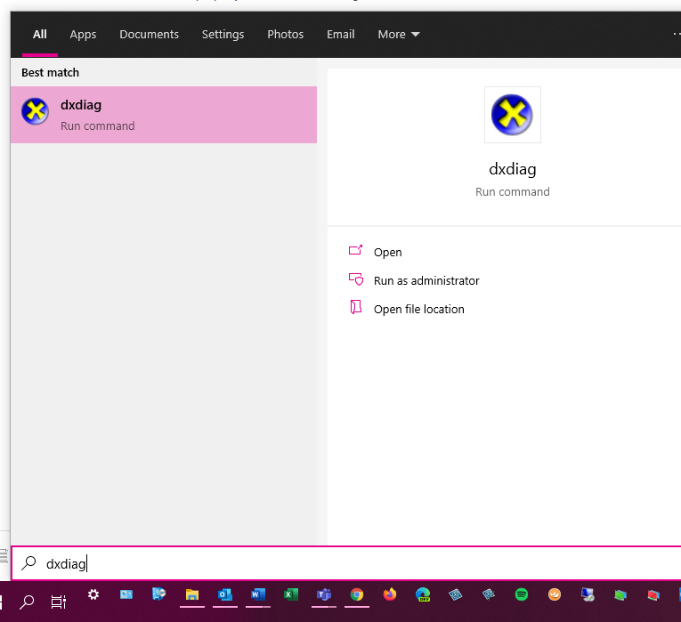

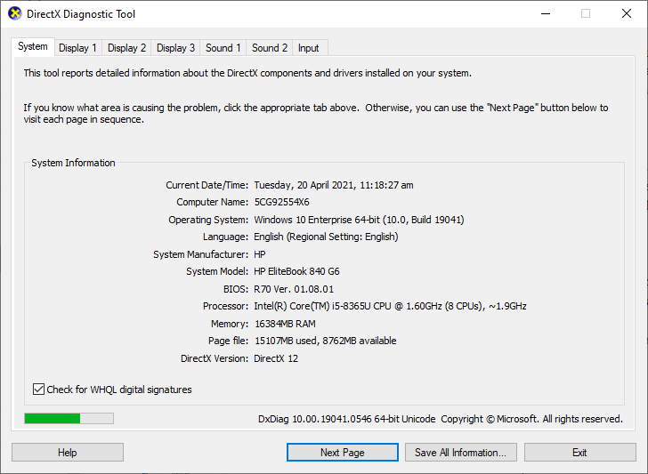

## Module 4 – Updating windows

Using group policy settings for configuring windows update

<https://youtu.be/g3AUR2gWhjk>

<https://youtu.be/708_pDfeTCk>

## Module 5 – configuring networking

DORA

Discover

Offer

Request

Acknowledge

[www.testconnectivity.microsoft.com](http://www.testconnectivity.microsoft.com)

Microsoft remote connectivity analyzer

[www.virustotal.com](http://www.virustotal.com)

can scan suspicious links sent in emails

<https://youtu.be/Ohjm-rUCq0g>

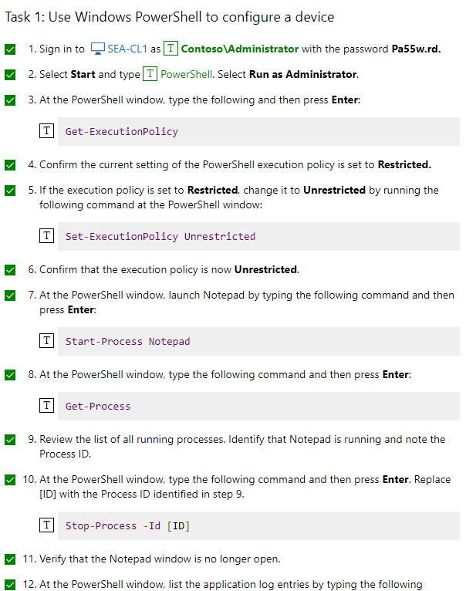

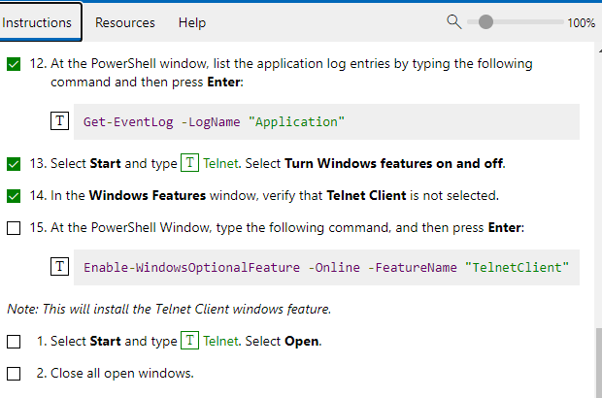

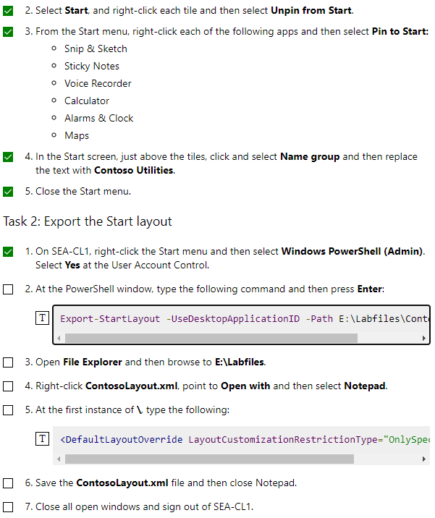

2. Export-StartLayout -UseDesktopApplicationID -Path E:\Labfiles\ContosoLayout.xml

5. <DefaultLayoutOverride LayoutCustomizationRestrictionType="OnlySpecifiedGroups">

Practice Lab: Managing Windows 10 Settings

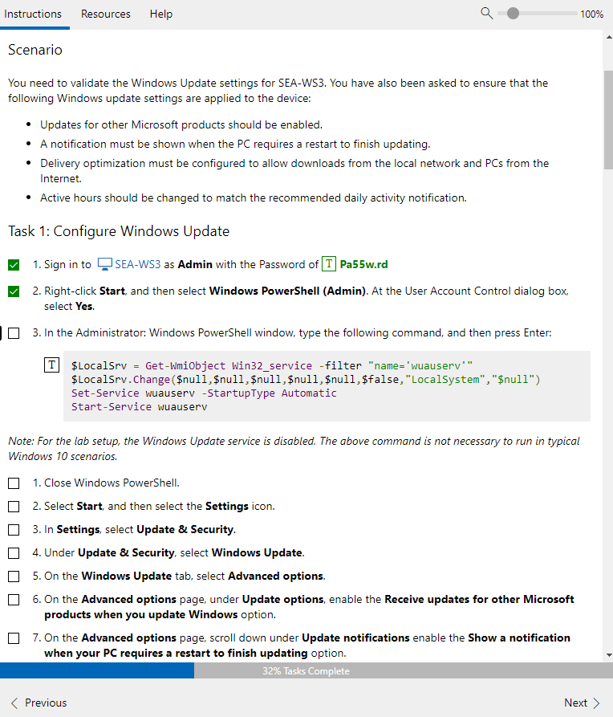

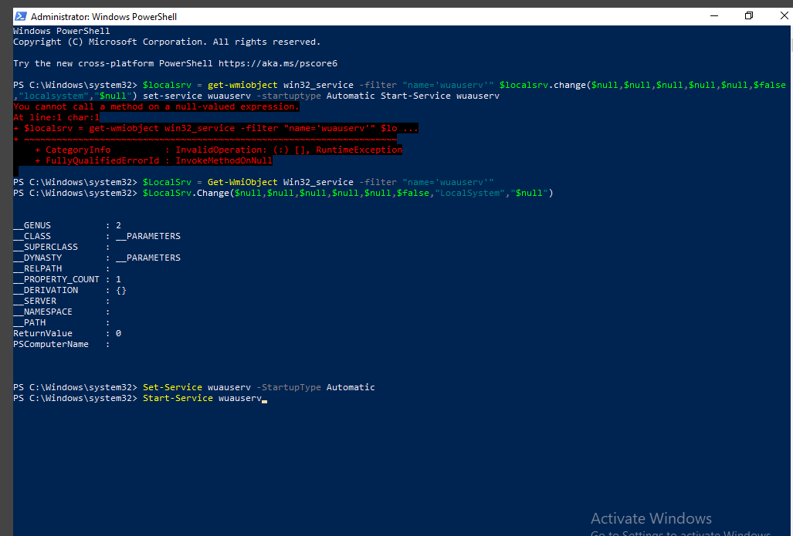

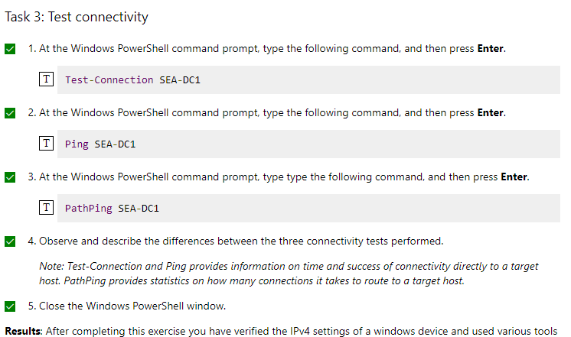

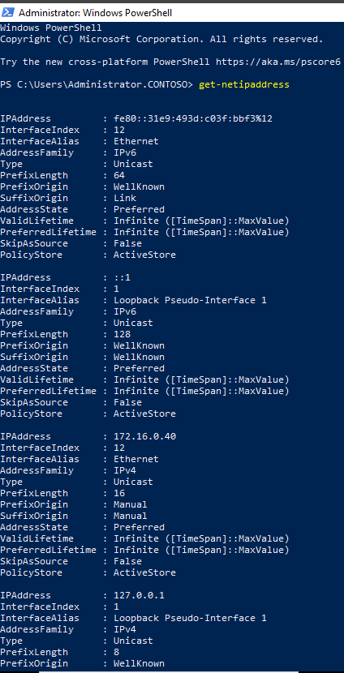

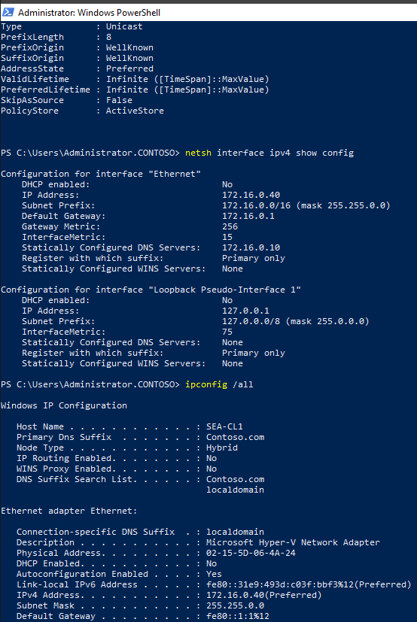

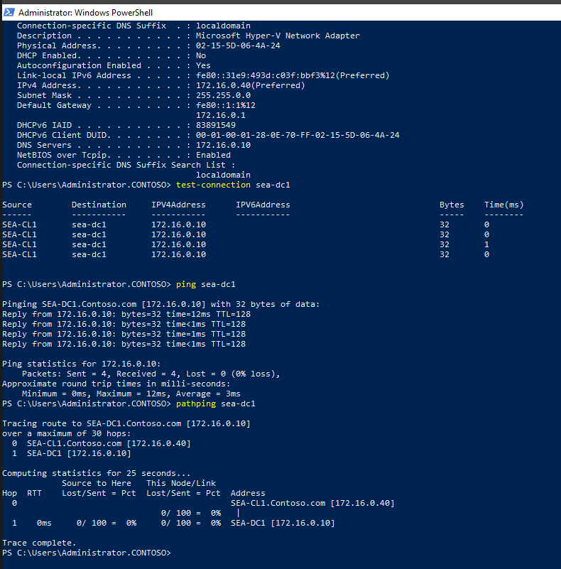

<https://youtu.be/Ynz83fzNY6M>

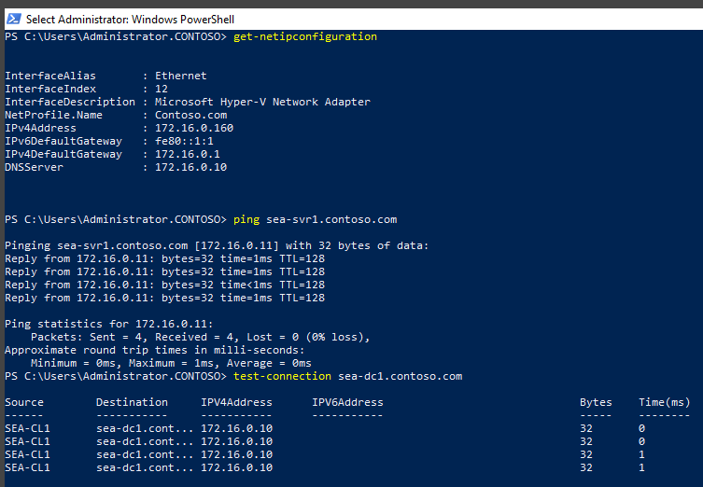

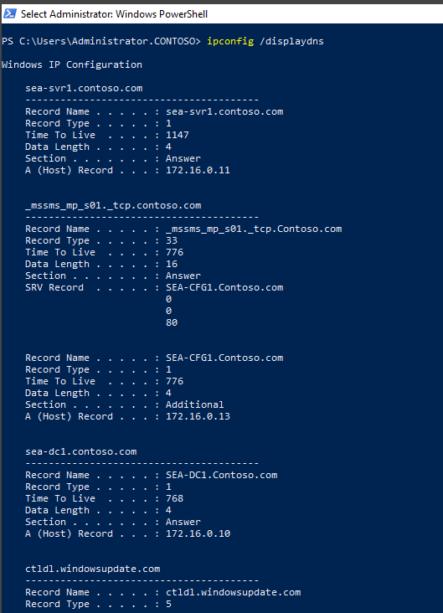

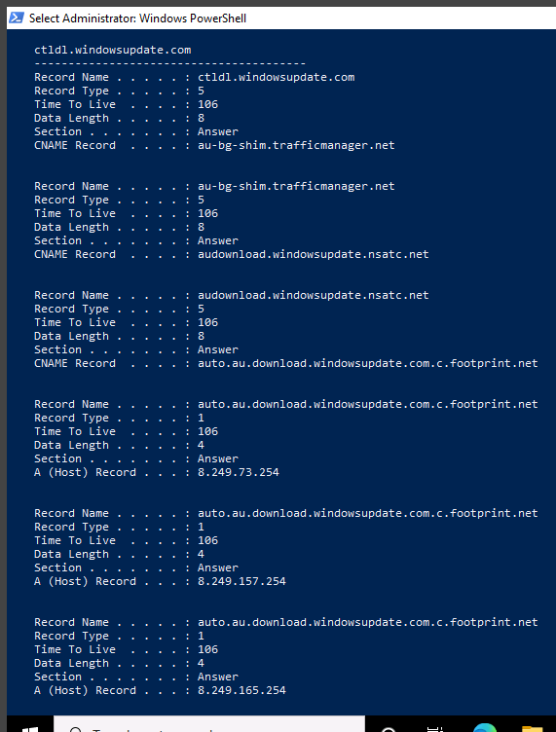

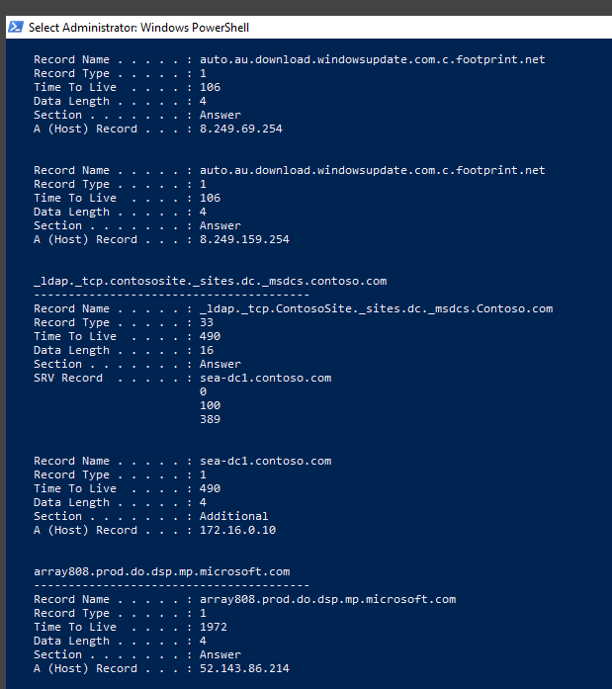

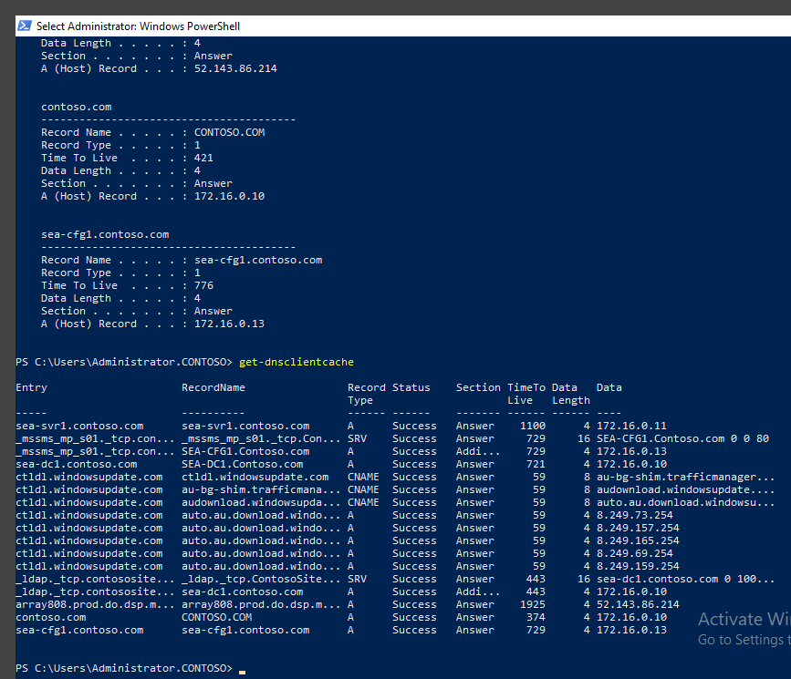

## Module 6 – Configuring storage

## Module 7 – Configuring data access and usage

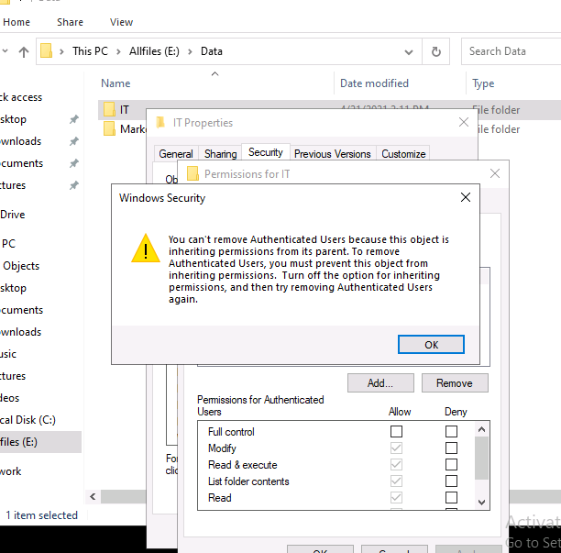

## Module 8 – Managing apps in windows 10

## Module 9 – configuring threat protection

Haveibeenpwned.com – check to see if your email account has been breached and website and password

Howsecureismypassword.net

Mcafee stinger application <https://www.mcafee.com/enterprise/en-us/downloads/free-tools/stinger.html>

<https://youtu.be/gRtKrzomS_Q>

<https://youtu.be/rRH34G590hc>

<https://youtu.be/J-9B04659vk>

<https://www.youtube.com/watch?v=YEBfamv-_do>

## Module 10 – Supporting the windows 10 environment

## Module 11 – Troubleshooting files and apps

## Module 12 – Troubleshooting the OS

Hold shift when clicking restart to go into recovery screen – keep holding shift while it restarts

<https://youtu.be/_1EjyO5i0cA>

## Module 13 – Troubleshooting hardware and drivers

<https://youtu.be/t2DH-BXbW8Q>

<https://metricsthatmatter.com/auldct47>

Windows memory diagnostic